Atfirst I have done some cleaning of the data and divided the table into some parts

Here I have divided the table customer_orders to cust_ord_details

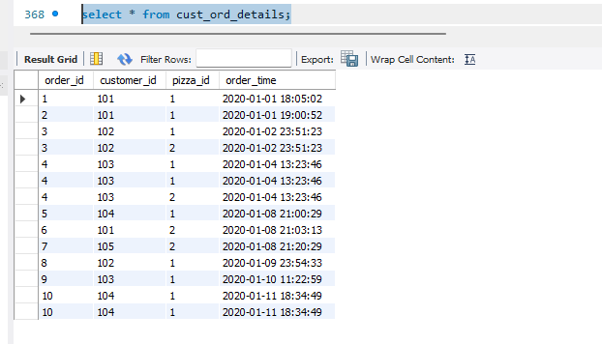

Cust_Pizza_Details table

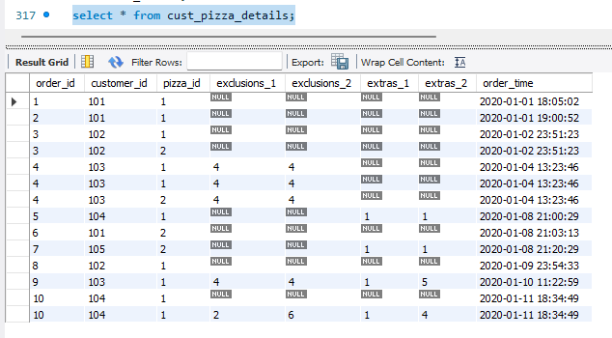

Pizza_toppings table to Pizza_topp

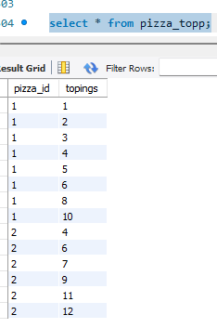

**Solution:**

**How many pizzas were ordered?**

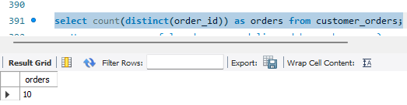

**How many successful orders were delivered by each runner?**

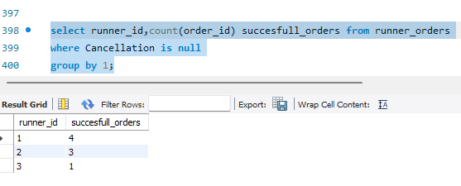

**How many of each type of pizza was delivered?**

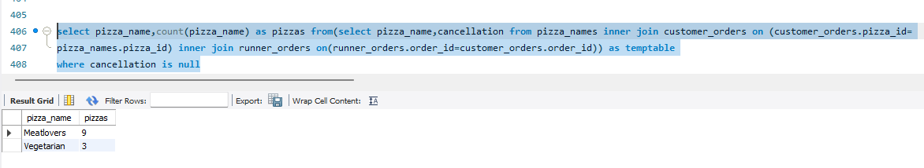

**How many Vegetarian and Meatlovers were ordered by each customer?**

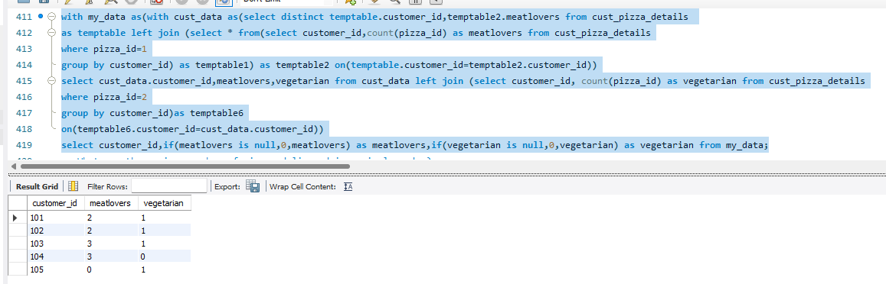

**What was the maximum number of pizzas delivered in a single order?**

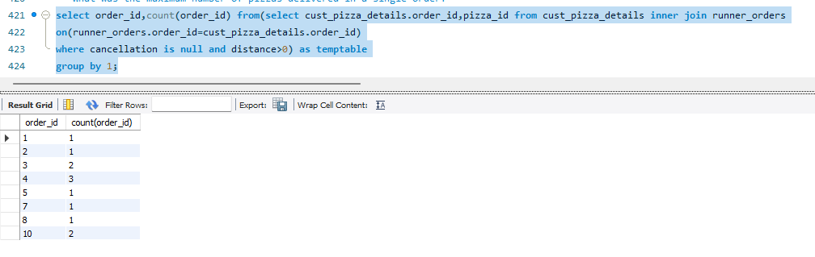

**For each customer, how many delivered pizzas had at least 1 change and how many had no changes?**

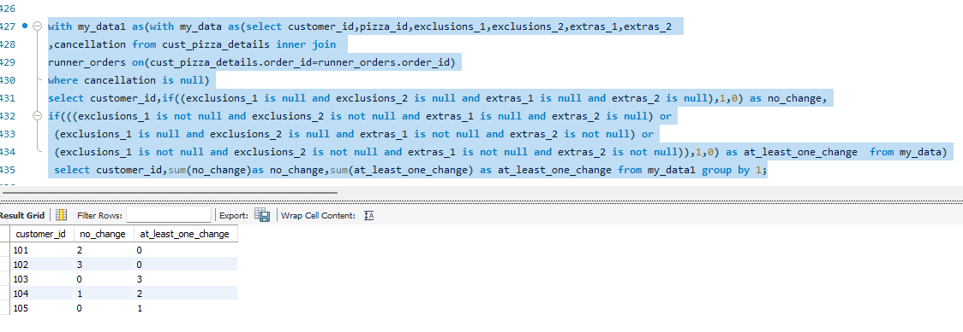

**How many pizzas were delivered that had both exclusions and extras?**

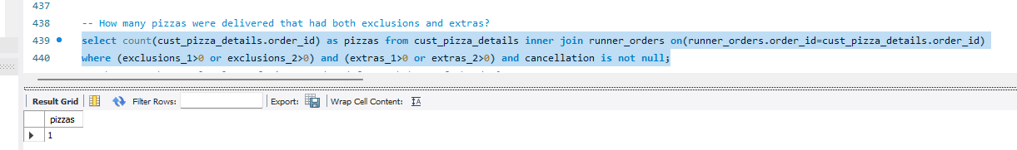

**What was the total volume of pizzas ordered for each hour of the day?**

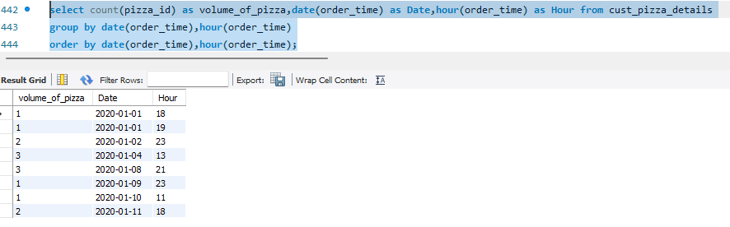

**What was the volume of orders for each day of the week?**

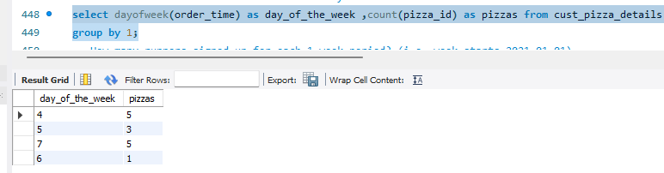

**How many runners signed up for each 1 week period? (i.e. week starts 2021-01-01)**

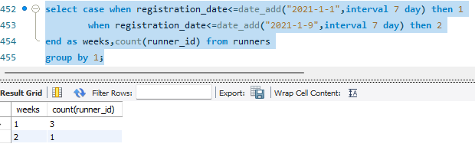

**What was the average time in minutes it took for each runner**

**to arrive at the Pizza Runner HQ to**

**pickup the order?**

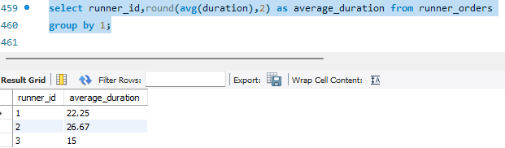

**Is there any relationship between**

**the number of pizzas and how long the order takes to prepare?**

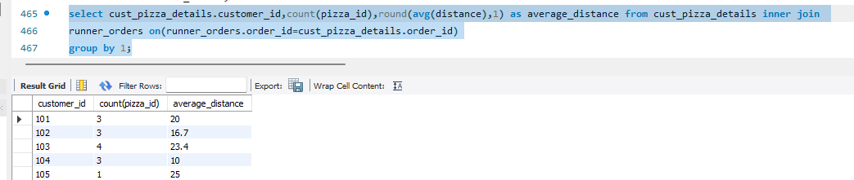

**Number of pizzas increases and time also increases but for the customer 104 and 102 may live near to the store so runners had travelled less distance to take place the order.**

**What was the average distance travelled for each customer?**

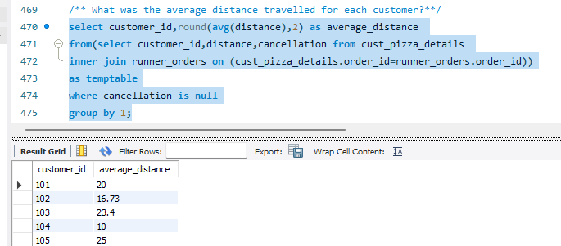

**104 is the nearest customer and 103 is the longest customer.**

**What was the difference between the longest and shortest delivery**

**times for all orders?**

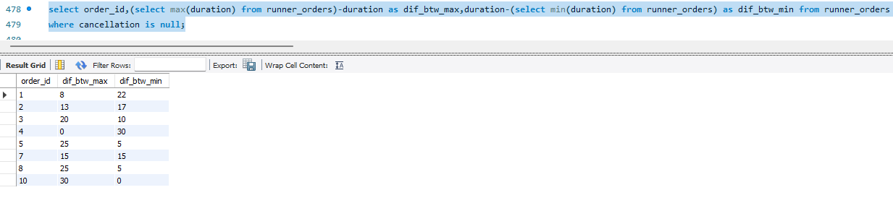

**What was the average speed for each runner for each**

**delivery and do you notice any trend for these values?**

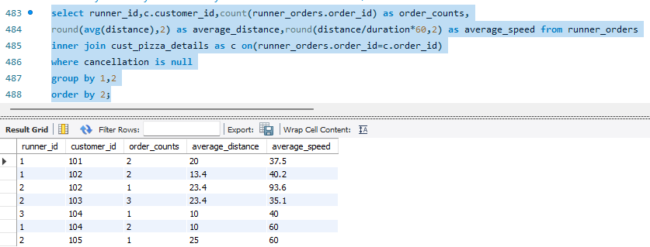

**What is the successful delivery percentage for each runner?**

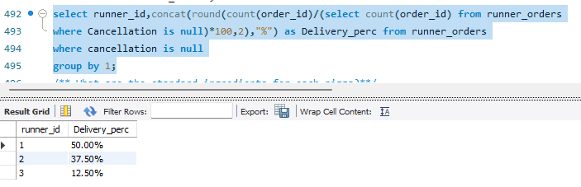

**What are the standard ingredients for each pizza?**

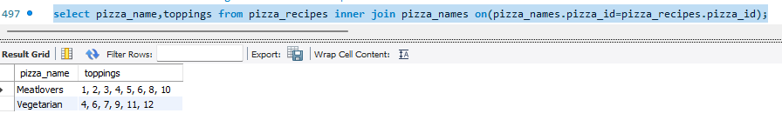

**What was the most commonly added extra?**

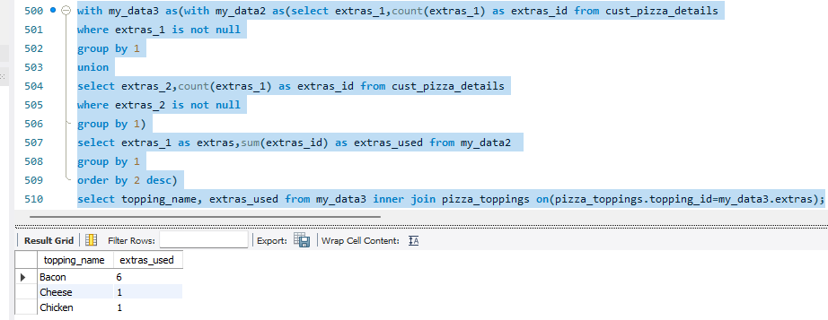

**What was the most common exclusion?**

**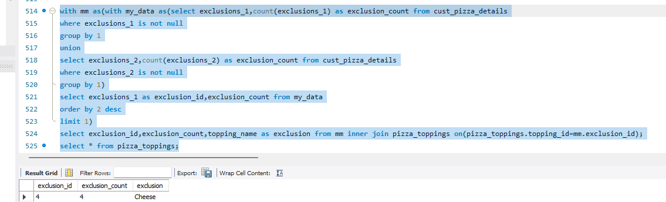  
Generate an order item for each record in the customers_orders table in the format of one of the following:**

**Meat Lovers**

**Meat Lovers - Exclude Beef**

**Meat Lovers - Extra Bacon**

**Meat Lovers - Exclude Cheese, Bacon - Extra Mushroom, Peppers**

**Code: select order_id,pizza_id,exclusions_1,exclusions_2,extras_1,extras_2,**

**if (exclusions_1 is null and extras_1 is null and exclusions_2 is null and extras_2 is null,**

**(select pizza_name from pizza_names where pizza_id=cust_pizza_details.pizza_id),if**

**(exclusions_1 is not null and exclusions_2 is null and extras_1 is null and extras_2 is null,concat(**

**(select pizza_name from pizza_names where pizza_id=cust_pizza_details.pizza_id),"-","Exclude"," ",**

**(select topping_name from pizza_toppings where topping_id=cust_pizza_details.exclusions_1)),**

**if(exclusions_1 is null and exclusions_2 is not null and extras_1 is null and extras_2 is null,concat**

**((select pizza_name from pizza_names where pizza_id=cust_pizza_details.pizza_id),"-","Exclude",**

**(select topping_name from pizza_toppings where topping_id=cust_pizza_details.exclusions_2)),**

**if(exclusions_1 is not null and exclusions_2 is not null and extras_1 is null and extras_2 is null,**

**concat((select pizza_name from pizza_names where pizza_id=cust_pizza_details.pizza_id),"-","Exclude"," ",**

**(select topping_name from pizza_toppings where topping_id=cust_pizza_details.exclusions_1),",",**

**(select topping_name from pizza_toppings where topping_id=cust_pizza_details.exclusions_2)),**

**if(exclusions_1 is null and exclusions_2 is null and extras_1 is not null and extras_2 is not null,**

**concat((select pizza_name from pizza_names where pizza_id=cust_pizza_details.pizza_id),"-","Extra"," ",**

**(select topping_name from pizza_toppings where topping_id=cust_pizza_details.extras_1),",",**

**(select topping_name from pizza_toppings where topping_id=cust_pizza_details.extras_2)),**

**if(exclusions_1 is null and exclusions_2 is null and extras_1 is not null and extras_2 is null,**

**(select topping_name from pizza_toppings where topping_id=cust_pizza_details.extras_1),**

**if(exclusions_1 is not null and exclusions_2 is not null and extras_1 is not null and extras_2 is not null,**

**concat((select pizza_name from pizza_names where pizza_id=cust_pizza_details.pizza_id),"-","Exclude"," ",**

**(select topping_name from pizza_toppings where topping_id=cust_pizza_details.exclusions_1),",",**

**(select topping_name from pizza_toppings where topping_id=cust_pizza_details.exclusions_2),"Extras","-",**

**(select topping_name from pizza_toppings where topping_id=cust_pizza_details.extras_1),",",**

**(select topping_name from pizza_toppings where topping_id=cust_pizza_details.extras_2)),if(exclusions_1 is not null and exclusions_2 is**

**null and extras_1 is not null and extras_2 is not null,concat((select pizza_name from pizza_names where pizza_id=cust_pizza_details.pizza_id),"-","Exclude"," ",**

**(select topping_name from pizza_toppings where topping_id=cust_pizza_details.exclusions_1)," ","Extras"," ",(select topping_name from pizza_toppings where topping_id=extras_1),",",**

**(select topping_name from pizza_toppings where topping_id=extras_2)),**

**(select topping_name from pizza_toppings where topping_id=cust_pizza_details.extras_2))))))))) as order_item**

**from cust_pizza_details;**

**Code:**

**select pizza_id,ingredient_1,ingredient_2,exclusions_1,exclusions_2,extras_1,extras_2,**

**if(ingredient_1 is null and ingredient_2 is null and exclusions_1 is null and exclusions_2 is null and extras_1 is null and extras_2 is null,(select**

**pizza_name from pizza_names where pizza_id=cust_pizza_details.pizza_id),**

**concat((select pizza_name from pizza_names where pizza_id=cust_pizza_details.pizza_id),":",(if(ingredient_1 is not null and ingredient_2 is not null and ingredient_1=ingredient_2,concat("2X"," ",(select topping_name from pizza_toppings where topping_id=cust_pizza_details.pizza_id)),"")),**

**if(exclusions_1 is null and exclusions_2 is null and extras_1 is null and extras_2 is null,"",if(exclusions_1 is not null and exclusions_2 is null and extras_1 is null and extras_2 is null,concat(",",(select topping_name from pizza_toppings where topping_id=cust_pizza_details.exclusions_1)),if(exclusions_1 is null and exclusions_2 is not null and extras_1 is null and extras_2 is null,concat(",",(select topping_name from pizza_toppings**

**where topping_id=cust_pizza_details.exclusions_2)),if(exclusions_1**

**is null and exclusions_2 is null and extras_1 is not null and extras_2 is null,**

**concat(",",(select topping_name from pizza_toppings where topping_id=**

**cust_pizza_details.extras_1)),if(exclusions_1 is null and exclusions_2**

**is null and extras_1 is null and extras_2 is not null,concat(",",(select topping_name from pizza_toppings where topping_id=cust_pizza_details.extras_2)),if(exclusions_1 is not null and exclusions_2 is not null and extras_1 is not null and extras_2 is not null and(exclusions_1=exclusions_2 or extras_2=extras_2),concat(",","2X",(select topping_name**

**from pizza_toppings where topping_id=cust_pizza_details.exclusions_1),",",(select topping_name from pizza_toppings where topping_id=cust_pizza_details.exclusions_2),",",(select topping_name from pizza_toppings where topping_id=cust_pizza_details.extras_1),",",(select topping_name from pizza_toppings**

**where topping_id=cust_pizza_details.extras_2)),**

**if(exclusions_1 is null and exclusions_2 is null and extras_1 is not null**

**and extras_2 is not null,concat(",",(select topping_name from pizza_toppings where topping_id=cust_pizza_details.extras_1),",",(select topping_name from pizza_toppings where topping_id=cust_pizza_details.extras_2)),if(exclusions_1 is not null and exclusions_2 is null and extras_1 is not null and extras_2 is not null,concat(",",(select topping_name from pizza_toppings where topping_id=**

**cust_pizza_details.exclusions_1),",",**

**(select topping_name from pizza_toppings where topping_id=cust_pizza_details.extras_1),",",(select topping_name from pizza_toppings where topping_id=cust_pizza_details.extras_2)),if(exclusions_1 is not null and exclusions_2 is not null and extras_1 is null and extras_2 is null,concat(",",(select topping_name from pizza_toppings where topping_id=**

**cust_pizza_details.exclusions_1),",",(select topping_name from pizza_toppings where topping_id=**

**cust_pizza_details.exclusions_2)),"1"))))))))))) as ingredeint_list from cust_pizza_details;**

**What is the total quantity of each ingredient used in all delivered pizzas sorted by most frequent first?**

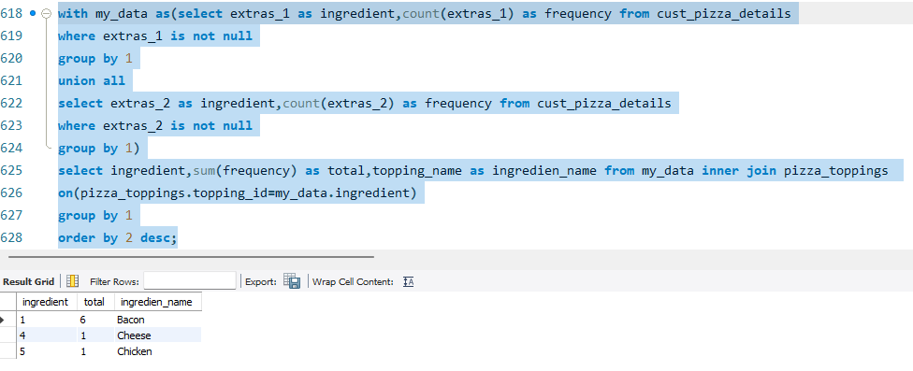

**If a Meat Lovers pizza costs $12 and Vegetarian costs $10**

**and there were no charges for changes - how much money has Pizza Runner made so far if there are**

**no delivery fees?**

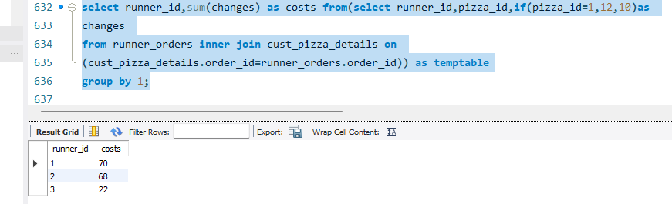

**What if there was an additional $1 charge for any pizza extras?**

**Add cheese is $1 extra?**

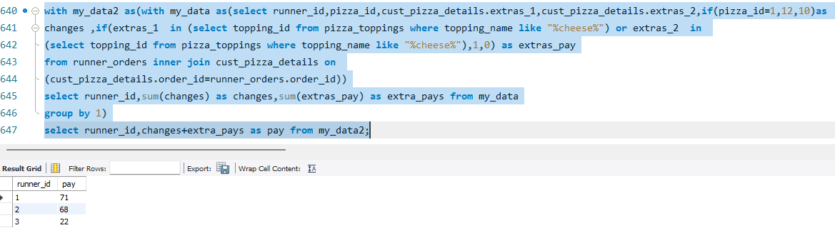

**The Pizza Runner team now wants to add an additional ratings system that allows customers to rate their runner, how would you design an additional table for this new dataset - generate a schema for this new table and insert your own data for ratings for each successful customer order between 1 to 5.**

**Using your newly generated table - can you join all of the information together to form a table which has the following information for successful deliveries?**

**customer_id**

**order_id**

**runner_id**

**rating**

**order_time**

**pickup_time**

**Time between order and pickup**

**Delivery duration**

**Average speed**

**Total number of pizzas**

**Code: create table pizza_ratings as(with data1 as(with mm as(with my_data3 as(with my_data2 as(with my_data1 as(with my_data as(select customer_id,order_id,pizza_id from cust_pizza_details**

**where order_id in(select order_id from runner_orders**

**where cancellation is null))**

**select customer_id,pizza_id,my_data.order_id,runner_id,duration,dense_rank() over(partition by customer_id order by duration asc) as ranks from my_data inner join runner_orders where(my_data.order_id=runner_orders.order_id)**

**order by customer_id,duration desc)**

**select customer_id,pizza_id,order_id,runner_id,duration,ranks,if (ranks=1,5,if(ranks=2,4,if(ranks=3,3,""))) as ratings from my_data1)**

**select distinct my_data2.customer_id,my_data2.pizza_id,my_data2.order_id,runner_id,duration,ratings,order_time from my_data2 inner join cust_pizza_details where my_data2.order_id=cust_pizza_details.order_id and my_data2.customer_id=cust_pizza_details.customer_id and my_data2.pizza_id=cust_pizza_details.pizza_id**

**order by 1)**

**select customer_id,pizza_id,my_data3.order_id,my_data3.runner_id,my_data3.duration,ratings,order_time,pickup_time from my_data3 inner join runner_orders where runner_orders.order_id=my_data3.order_id and runner_orders.runner_id=my_data3.runner_id)**

**select customer_id,mm.pizza_id,mm.order_id,mm.runner_id,mm.duration,ratings,order_time,mm.pickup_time,abs(minute(mm.pickup_time)-minute(mm.order_time)) as time_diff,distance from mm inner join runner_orders on(runner_orders.order_id=mm.order_id))**

**select customer_id,order_id,count(pizza_id) as pizzas,runner_id,duration,ratings,order_time,pickup_time,time_diff,round(distance/duration*60,2) as average_speed from data1**

**group by 1,2,4);**

**Thank You!**